EXPERIMENT 2
Semantic Search using Cosine Similarity
Name | P Nishanth
Register Number | 192472292

AIM
To develop a semantic search system by comparing document vectors and a query vector using cosine similarity.

PROCEDURE
- Import TfidfVectorizer and cosine_similarity.
- Create sample documents and define a search query.
- Convert the documents and query into TF-IDF vectors.
- Calculate cosine similarity between the query and document vectors.
- Display the similarity scores and the best matching document.

PROGRAM
from sklearn.feature_extraction.text import TfidfVectorizer from sklearn.metrics.pairwise import cosine_similarity

documents = [
"The sun gives light and heat.",
"Python is used for programming.",
"A computer can process information."
]

query = "Which language is used to write programs?"

vectorizer = TfidfVectorizer() doc_vectors = vectorizer.fit_transform(documents) query_vector = vectorizer.transform([query])

similarity = cosine_similarity(query_vector, doc_vectors)[0]

print("Query:", query) print("\nDocument Similarity:") for i, score in enumerate(similarity):
print(documents[i], "->", round(score, 3))

best = similarity.argmax() print("\nBest Match:") print(documents[best]

OUTPUT

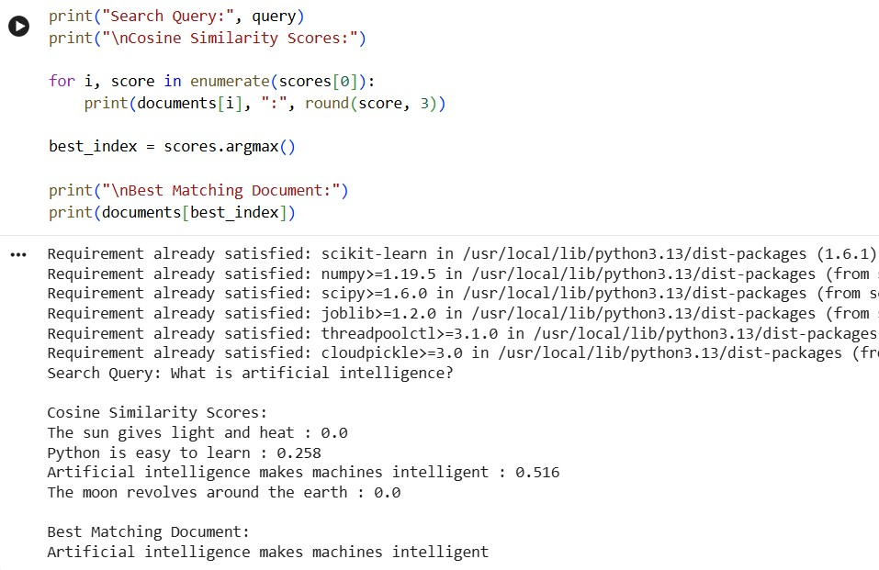

RESULT
Thus, document search was performed by comparing query and document vectors using cosine similarity.
Note: Install: pip install scikit-learn. TF-IDF is used as a simple local vectorization method.

